Fact Check: Lavrov DID NOT Ask WHO To Recognize The Existence Of Biological Labs In Bulgaria, And The News Was Not Reported By Reuters

проверка на факти
- Jun 26, 2023
- от: Lead Stories Staff
Сподели Tweet
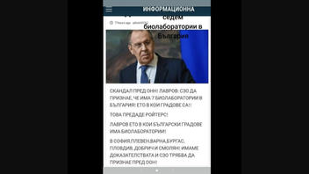No Bio Labs
Did the Minister of Foreign Affairs of the Russian Federation Sergei Lavrov, in a speech before the UN, ask the WHO to recognize the existence of seven biological laboratories in seven of the largest Bulgarian cities, and was the news covered by Reuters? No, that's not true: Reuters did not report such news. The existence of such information or similar reports cannot be found on the Reuters website as well as it's not reported by any other credible media. There is no evidence to confirm that the claims circulating on social media are true or that Lavrov said they have proof of the biological laboratories, and the UN needs to acknowledge their existence.
The claim appeared in a Bulgarian video (no longer available) on TikTok, published by @random1133554 on June 21, 2023.
The Bulgarian text overlay reads:
Scandal at the UN! Lavrov: The WHO should admit that there are seven bio labs in Bulgaria! Here are the cities they are in!
This was reported by Reuters.
Lavrov, here are the Bulgarian cities in which there are bio labs: Sofia, Pleven, Varna, Burgas, Plovdiv, Dobrich, and Smolyan! We have evidence, and the WHO must admit the existence of such labs to the UN!
This is what the post looked like on TikTok while it was still available:
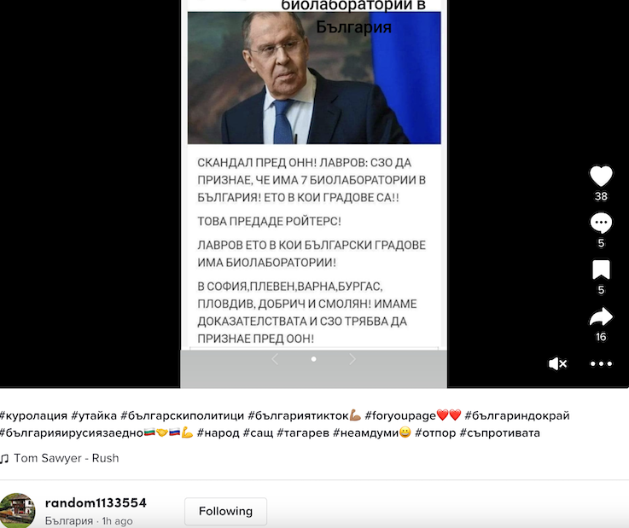
(Source: TikTok screenshot taken on Wed Jun 21 12:58:11 2023 UTC)
The official government website of the Ministry of Foreign Affairs of Russia tracks Lavrov's visits and speeches, but no recent speeches or travel related to the claims in the video are found. According to the press service of the Ministry of Foreign Affairs of the Russian Federation, the most recent visit of Lavrov to the US, New York, and the UN Security Council, mentioned on the website, is from April 24, 2023.
A reverse image search finds that the source of the photo is Reuters but the article is from February 14, 2022, and it's about Lavrov and possible diplomatic solutions to the imminent military conflict with Ukraine. The photo has been processed with a slight rotation of the image to make possible image reverse search more difficult.
A screenshot of the original picture that was taken from the Reuters article can be seen here:
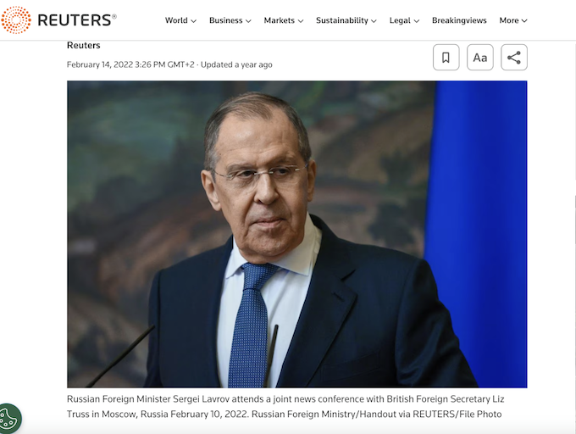
The image from the TikTok video is cropped and additionally edited by a slight rotation. Both pictures in a mixed image reveal the change. The result can be seen here:
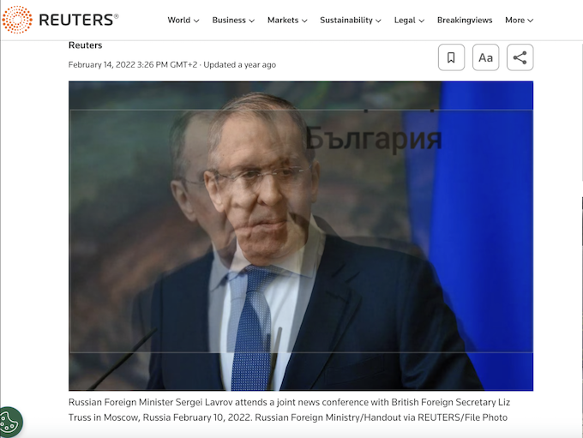
The result of the TikTok picture superimposed on top of the original photo as an example can be seen here:
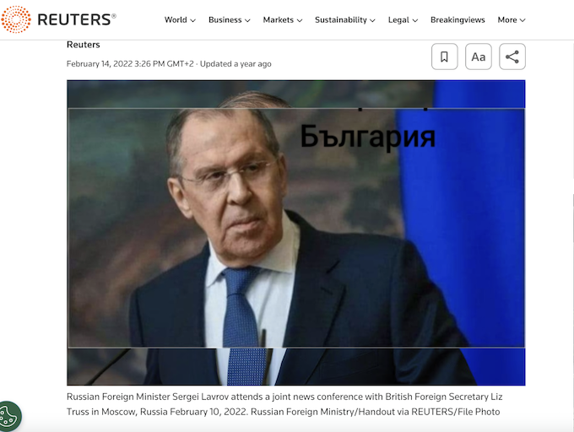
Russian false claims related to bio labs and the creation of biological weapons have become more active since the beginning of the Russian invasion of Ukraine. Russia has accused the US and Ukraine of illegally developing biological weapons in American bio labs located on Ukrainian territory. These claims have been repeatedly debunked by the Lead Stories team.
Similar news became popular in Bulgaria around July 2022. In one of the already debunked reports, Sergei Shoigu claimed that there are bio labs in Bulgaria where experiments are conducted on Bulgarian citizens. This claim was debunked in a detailed investigation by several media, including the Bulgarian National Radio (BNR).

